Temperature Monitor.vi
Name: Baek Seunghyeon
Student no.: 3035821659
Programme: CE

This VI is the solution to an exercise in the LabVIEW Core 1 course.

It uses a While Loop and shift registers to average data. No hardware is necessary.

Connector Pane


Front Panel
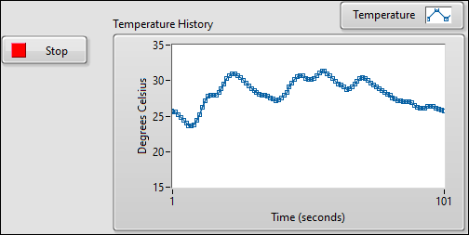

Block Diagram
